
SIMPLICITY

Microsoft Dynamics Snap

Vacation Management Snap-in

White Paper

Technical Pre-release Version 1.0 for Microsoft Dynamics TM AX 4.0 / 2007 Microsoft® Office system

February 10, 2007

Microsoft Dynamics Snap Sandbox

Table of Contents
Executive Summary 3
Executive Summary 3
INTRODUCING MICROSOFT DYNAMICS SNAP 3
Microsoft Dynamics Snap for Vacation Management 4
Functional Overview 5
View Details of Previous Vacations 6
FilE a New Vacation Request 7
Approve or Reject vacation requests 8
High level architecture 9
PRE-Requisites for using this Snap-in 9

Executive Summary

Executive Summary
Many corporations implement business application systems like Microsoft Dynamics™ to automate their back-office business processes. Oftentimes though, it can be quite tedious to get information into those systems even requiring people to keep multiple records of the same activity which if course, gives rise to greater opportunity for errors. What if there were ways to enable information workers to get relevant data into their Microsoft Dynamics applications from within Microsoft Office?

INTRODUCING MICROSOFT DYNAMICS SNAP
Microsoft Dynamics Snap applications do just that—they allow information workers to interact easily with Microsoft Dynamics, thereby increasing their productivity and enabling them to get timely and accurate information into their system from within the Microsoft Office applications they are most comfortable with and with which they are most familiar. Microsoft Dynamics Snap applications help companies maximize their investment in Microsoft technology by delivering the power of the Microsoft Dynamics business applications to every single employee.

Microsoft Dynamics Snap for Vacation Management

The Vacation Management Snap-in allows an Information Worker to use Microsoft Outlook® to file vacation times into Microsoft Dynamics AX 4.0. Their manager receives a notification of the request via their email. The manager can then view the details of the vacation request and approve or reject it, all without ever leaving Microsoft Outlook.

By using the Vacation Management Snap-in, an Information worker can
- Create new Vacation records in Microsoft Dynamics AX for vacations that have been taken or those planned in the future
- Save vacation requests for future editing or post them for approval
- Get email notifications of all pertinent vacation requests.
  - Status Change: for vacation requests they have filed
  - Pending Approval: for vacation requests which need their approval
- View history of their vacations or of those for which they are an approver
- Approve or Reject the vacation requests for which they are the approver

Kicking-off a vacation request is as easy as sending an email. And equally straightforward is to view the vacation history and give approval to such a request. The Vacation Management Snap-in simplifies the entire process, saving time and reducing data duplication errors while allowing Information Workers to use the Microsoft Office applications they are most familiar with to get things done.

Functional Overview
The Vacation Management snap-in allows a user to view or submit vacation requests while remaining within Outlook. Here are the features of the application:
- View summarized or detailed information about absences that have been previously submitted
- File new vacation requests
- Make changes to previously submitted requests whether they were filed using the Microsoft Dynamics AX 4.0 or Outlook.
Most business users use Outlook while planning their vacations. But, to actually file their time off, they have to log in to Microsoft Dynamics AX 4.0, thus switching applications and context.
The Vacation Management snap-in allows a user to view or submit vacation requests while remaining within Outlook. The submitted vacation requests trigger an email to an approver who can view details of the requested vacation and the vacation history of the requestor. The approver, then, has all the information necessary to approve or reject the request.
The following screenshots demonstrate how easy it is to manage your vacation time by using the Vacation Management snap-in.

View Details of Previous Vacations
To plan a leave of absence, an employee can view their Vacation history right from Outlook. To view a summary of, or details about, past absences, including their status, use the Vacation Management History view in Outlook (Click on the Vacation button in the toolbar to launch this). You can summarize the view by various fields, and view details of individual vacation entries or edit them.

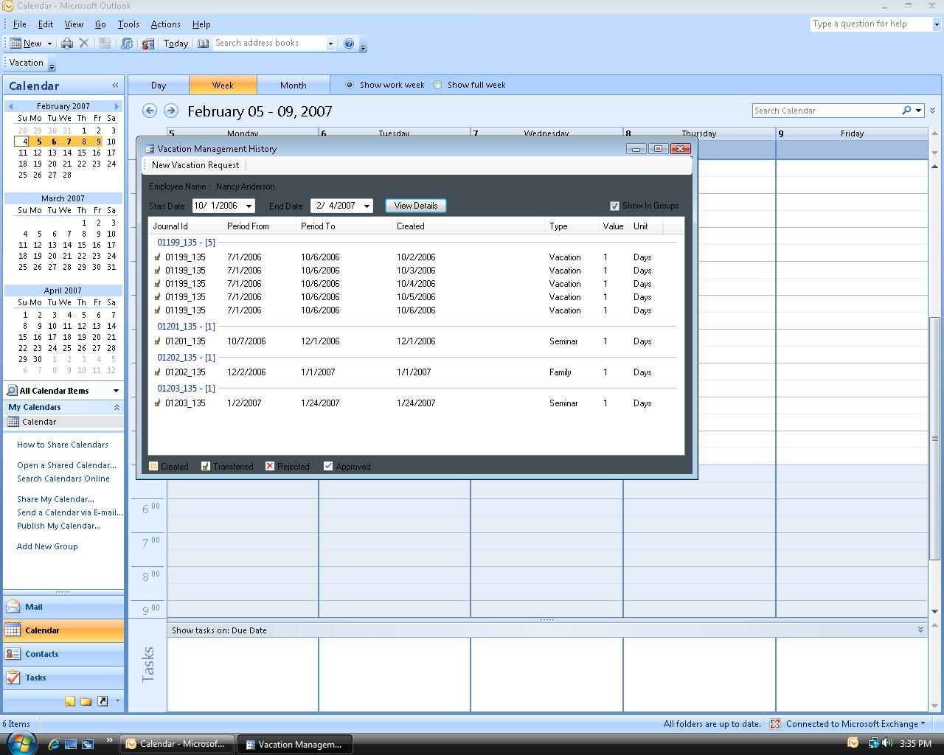

FilE a New Vacation Request
A new vacation request can be created by clicking New Vacation Request in the Vacation Management History window.
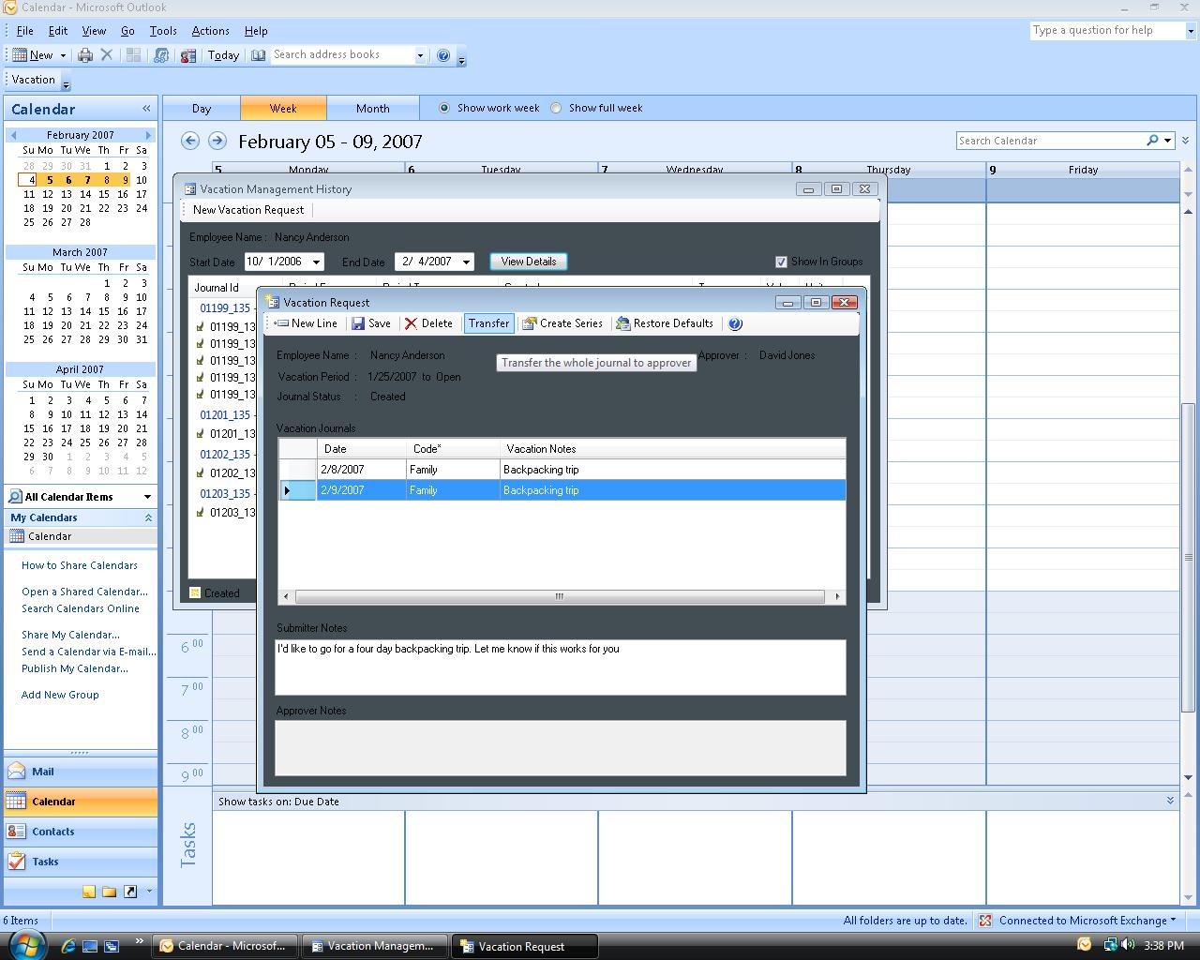

Approve or Reject vacation requests
After a vacation is request is submitted, an e-mail message is sent to the approver. From within Outlook, the approver can view the details of request and the absence history of the requestor. The approver can approve or reject the request immediately by using the buttons on the Outlook toolbar or click Vacation Details to open the Vacation Request form and add comments before approving or rejecting the request

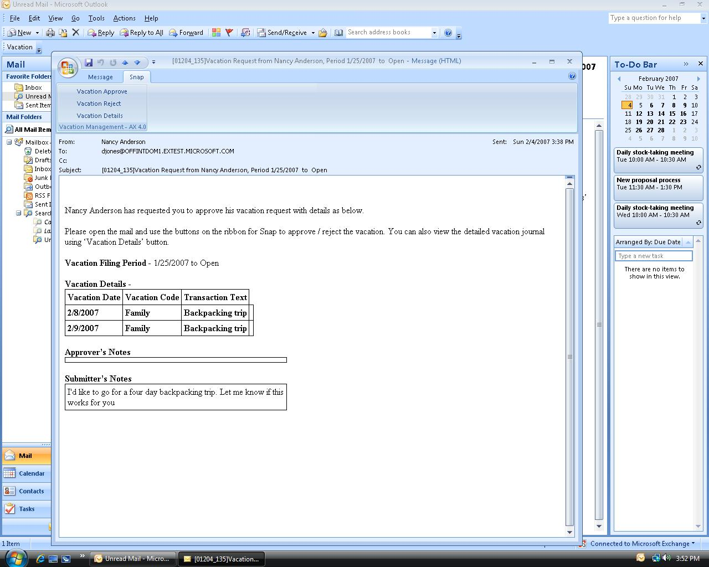

High level architecture

The Vacation Management snap-in uses the Outlook Object Model (OOM) to add toolbar buttons in Outlook which serves as its entry point. Buttons are added to the ribbon in the mail item through the OOM. When one of these buttons is clicked, it invokes the Vacation Management forms. The snap-in then retrieves or updates data into the Microsoft Dynamics AX 4.0 database using AX 4.0 Business Connector.
This is a diagram of the Vacation Management snap-in architecture.
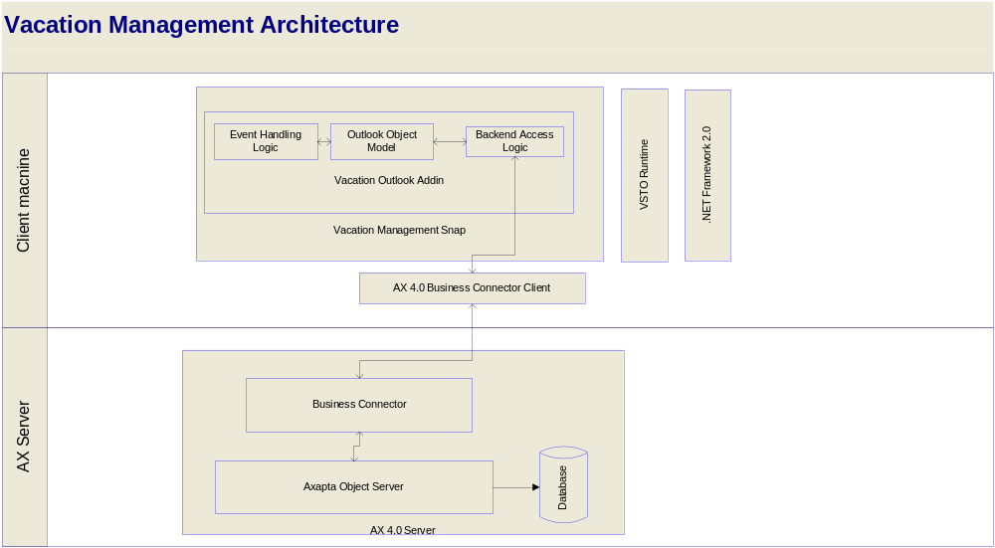

PRE-Requisites for using this Snap-in
- Microsoft Office 2007 should be installed, along with all the latest updates, and Microsoft Outlook should have been run at least once on the local machine
- Microsoft Dynamics AX 4.0 SP4 client and Business Connector 4.0 should be installed on the local machine with an active configuration that can access the Microsoft Dynamics AX 4.0 Server
- The user must have permissions and access to the Microsoft Dynamics AX 4.0 server
- Microsoft .NET Framework 2.0 should be installed on the system
- Microsoft VSTO 2005 SE Runtime should be installed on the system
The complete set of pre-requisites can be found in the installation guide.
The information contained in this document represents the current view of Microsoft Corporation on the issues discussed as of the date of publication. Because Microsoft must respond to changing market conditions, this document should not be interpreted to be a commitment on the part of Microsoft, and Microsoft cannot guarantee the accuracy of any information presented after the date of publication.
This White Paper is for informational purposes only. MICROSOFT MAKES NO WARRANTIES, EXPRESS, IMPLIED, OR STATUTORY, AS TO THE INFORMATION IN THIS DOCUMENT.
Complying with all applicable copyright laws is the responsibility of the user. Without limiting the rights under copyright, no part of this document may be reproduced, stored in or introduced into a retrieval system, or transmitted in any form or by any means (electronic, mechanical, photocopying, recording, or otherwise), or for any purpose, without the express written permission of Microsoft Corporation.
Microsoft may have patents, patent applications, trademarks, copyrights, or other intellectual property rights covering subject matter in this document. Except as expressly provided in any written license agreement from Microsoft, the furnishing of this document does not give you any license to these patents, trademarks, copyrights, or other intellectual property.

© 2006 Microsoft Corporation. All rights reserved.
Microsoft, the Microsoft Dynamics Logo, Microsoft Office Outlook, BizTalk, Dexterity, FRx, Microsoft Dynamics, SharePoint, Visual Basic, Visual C++, Visual SourceSafe, Visual Studio, Windows, and Windows Server are either registered trademarks or trademarks of Microsoft Corporation, FRx Software Corporation, or Microsoft Business Solutions ApS in the United States and/or other countries. Microsoft Business Solutions ApS and FRx Software Corporation are subsidiaries of Microsoft Corporation.
Microsoft Dynamics is a line of integrated, adaptable business management solutions that enables you and your people to make business decisions with greater confidence. Microsoft Dynamics works like and with familiar Microsoft software, automating and streamlining financial, customer relationship and supply chain processes in a way that helps you drive business success.

U.S. and Canada Toll Free 1-888-477-7989
Worldwide +1-701-281-6500
www.microsoft.com/dynamics
Part No. 0000-0000 (02/07)

